**US 004-TC 004_002: Verify functionality of "ADD TO CART" button**

Step 1: Navigate to swag labs site

Step 2: Login as "standard_user" into the website

Step 3: Click on the "ADD TO CART" button in any product.

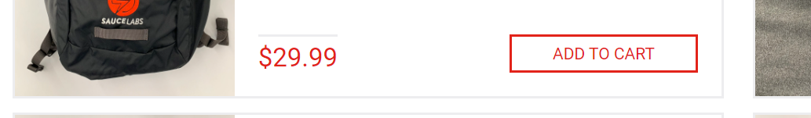

**User is able to add items to cart using ADD TO CART**

**Test case Passed.**